Meta Title
Amarnath Cave Temple Darshan Timings, Yatra & Info
Meta Description
Explore Amarnath Cave Temple darshan timings, history, & Yatra travel info. Plan your holy pilgrimage and experience Lord Shiva's divine blessings.
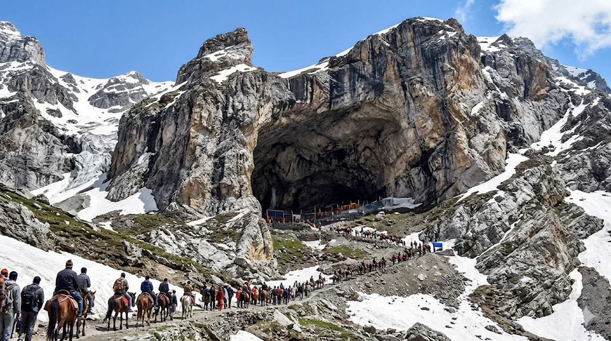
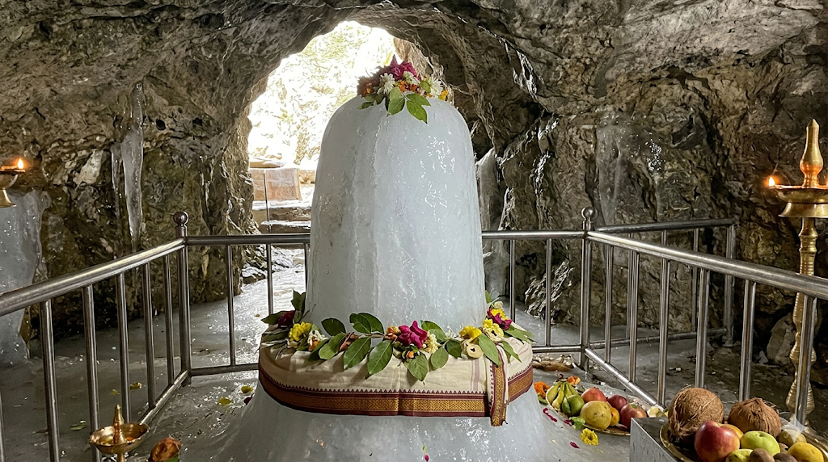

Amarnath Cave Temple - Darshan Timings, History & Yatra Information
Experience the ultimate test of devotion and the supreme divine presence of Lord Shiva at the sacred Amarnath Cave Temple in Anantnag, Jammu & Kashmir. Situated at a breathtaking altitude of 3,888 meters (12,756 feet) amidst the snow-capped Himalayas, this revered shrine is home to the naturally forming Ice Shiv Lingam—a miraculous manifestation of Baba Barfani that waxes and wanes with the phases of the moon.
Embark on the journey of a lifetime with expert guidance. Avoid the extreme physical exhaustion, unpredictable weather risks, and complex registration hassles with our meticulously planned travel assistance.
👉 [Click here to book your Assisted Amarnath Yatra & Helicopter Package]

Amarnath Cave Temple – Quick Info
- Location: Baltal/Pahalgam, Anantnag District, Jammu & Kashmir
- Deity: Lord Shiva (worshipped as Baba Barfani / Amarnath)
- Significance: One of the holiest shrines in Hinduism; the site where Lord Shiva revealed the secret of immortality.
- Unique Feature: The naturally forming Ice Lingam, accompanied by two smaller ice formations representing Goddess Parvati and Lord Ganesha.

The Story of Amarnath Cave – The Secret of Immortality
The history of the Amarnath Cave Temple is a profound tale of divine love and eternal secrets. According to ancient Hindu scriptures, Goddess Parvati asked Lord Shiva to reveal the Amar Katha—the absolute secret of life and immortality. To ensure no living being could hear this sacred knowledge, Lord Shiva chose this remote, desolate cave deep in the Himalayas.
On his way to the cave, Shiva left behind his earthly companions: his bull Nandi at Pahalgam, the moon from his hair at Chandanwari, his snakes at Lake Sheshnag, his son Ganesha at Mahagunas Parvat, and the five elements (Panchamahabhutas) at Panjtarni. He even created a fire to destroy any living entity inside the cave. However, a pair of mating doves remained hidden beneath his deer skin and heard the secret, rendering them immortal. Devotees believe these immortal doves can still be seen near the cave today.
Understanding this divine history transforms your challenging trek into a deeply emotional and spiritual awakening. When you bow before the Ice Lingam, you are standing in the very spot where the universe's greatest secret was unveiled.
👉 [Let us make your Himalayan Yatra safe and effortless. Explore our complete Travel Packages]
Devotees deeply believe that:
- A darshan of Baba Barfani breaks the cycle of life and death, granting Moksha (liberation).
- Enduring the physical hardship of the Yatra purifies the soul of all past karmas.
- The holy ash (Bhasma) from the cave provides divine protection and healing.

Amarnath Yatra Timings & Schedule
Note: The Amarnath Cave Temple is NOT open year-round. It only opens for a brief 40 to 45-day window during the summer months (usually July to August), coinciding with the holy month of Shravan.
Ritual / Darshan | Timing (Approximate) | Notes
Yatra Season | Late June to August (Shravan) | Exact dates announced by SASB annually
Cave Opening | 6:00 AM | Morning Darshan begins
Morning Aarti | 7:00 AM – 8:00 AM | Chanting and prayers
General Darshan | 8:00 AM – 5:00 PM | Continuous moving queue
Evening Aarti | 6:00 PM – 7:00 PM | Grand evening prayers
Cave Closure | 8:00 PM | Darshan halts for the night
Best Time for Darshan: Morning darshan is ideal, but reaching the cave requires careful scheduling depending on your base camp (Baltal or Pahalgam) and mode of transport (trekking vs. helicopter).
👉 [Secure your Yatra Registration and Helicopter slots with Vandan Darshan]

The Two Sacred Routes
The Yatra can be undertaken via two distinct paths:
- The Pahalgam Route (Traditional): A 36 to 48 km trek taking 3-5 days. It is incredibly scenic, passing through Chandanwari, Sheshnag, and Panchtarni.
- The Baltal Route (Shorter): A steep 14 km trek taking 1-2 days. It is physically demanding but saves time.

How to Reach the Base Camps
- By Air: Srinagar International Airport (SXR) is the nearest major airport.
- By Train: Jammu Tawi or Udhampur Railway Stations are the major railheads, from where taxis or buses transport you to the base camps.
- By Road: Well-connected from Srinagar to both Baltal (90 km) and Pahalgam (90 km).
👉 [Need a Srinagar airport pickup or a premium SUV for the hills? Book comfortable travel with Vandan Darshan]

Hotels & Base Camp Accommodations
Stay Options:
- Pre-fabricated huts and tented accommodations at Baltal, Nunwan, and Panchtarni.
- Premium Hotels and Resorts in Sonamarg and Pahalgam for pre- and post-Yatra rest.

Plan Your Amarnath Yatra
Planning your pilgrimage to the icy heights of Baba Barfani? Ensure your family members travel safely, meet all medical requirements, and navigate the difficult terrain comfortably.
With Vandan Darshan, you can book:
- Helicopter Tickets (Baltal to Panchtarni / Pahalgam to Panchtarni)
- Compulsory Health Certificate (CHC) & Yatra Registration Assistance
- Travel, AC SUVs, & Comfortable Tents/Hotel Stays
- Pony, Palki, and Porter Coordination
[Click Here to Visit our Dedicated Amarnath Yatra Booking & Helicopter Services Page]

Info & FAQs – Amarnath Cave Temple
Where is Amarnath Cave Temple located?
The temple is located in a narrow gorge at the end of the Lidder Valley in the Anantnag district of Jammu and Kashmir, India.
Why is Amarnath Temple famous?
It is globally renowned for the natural formation of an ice stalagmite representing the Shiva Lingam, and for being the sacred site where Lord Shiva narrated the secret of eternity to Goddess Parvati.
When does the Amarnath Yatra happen?
The Yatra typically takes place over 40-45 days during the summer months of July and August, concluding on Shravan Purnima (Raksha Bandhan).
Is medical registration mandatory?
Yes. Every pilgrim must obtain a Compulsory Health Certificate (CHC) from authorized doctors and complete the official Shri Amarnathji Shrine Board (SASB) registration before undertaking the journey.
Can senior citizens do the Yatra?
The SASB restricts children below 13 years, elderly persons above 70-75 years, and pregnant women from undertaking the Yatra due to low oxygen and tough terrain.
How can I arrange my Amarnath Yatra safely?
You can pre-book your complete itinerary—including Srinagar airport transfers, Pahalgam/Baltal hotel stays, Helicopter tickets, and registration assistance—through Vandan Darshan. [Contact us today to book your spiritual package].

